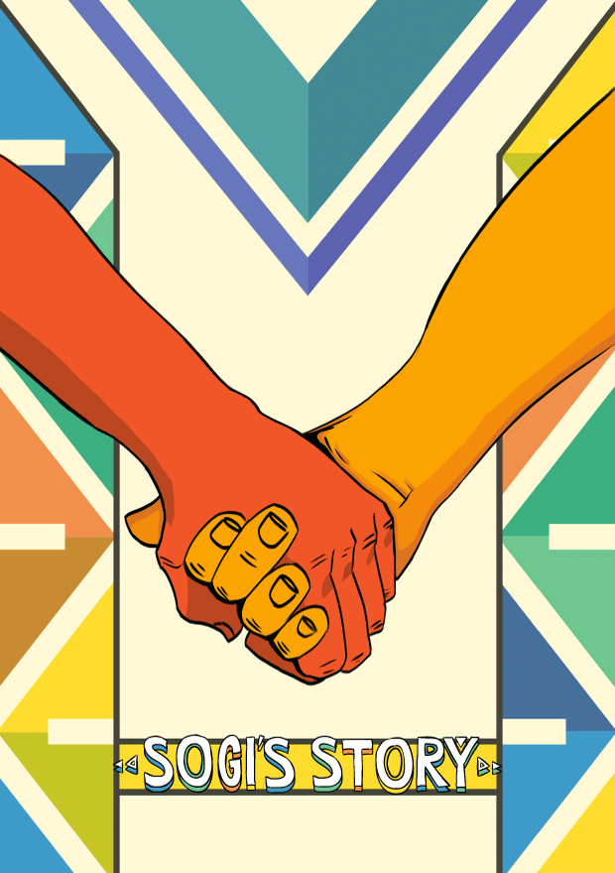 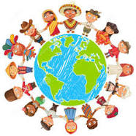

**Sexuality**

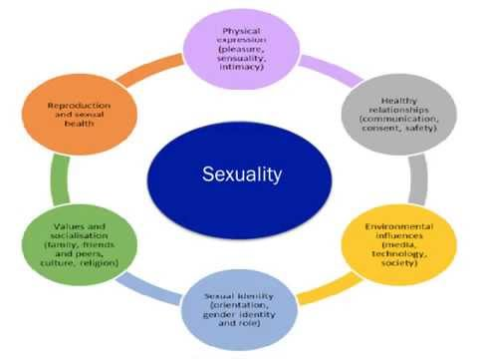**Sexuality** encompasses nearly every aspect of our being, from attitudes and values, to feelings and experiences. ... Our attitudes and behaviors toward our health and the consequences of sexual activity. This includes: Our use of power and influence to manipulate or control others with our sexuality.

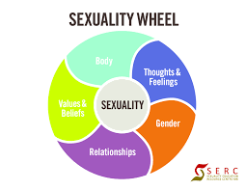

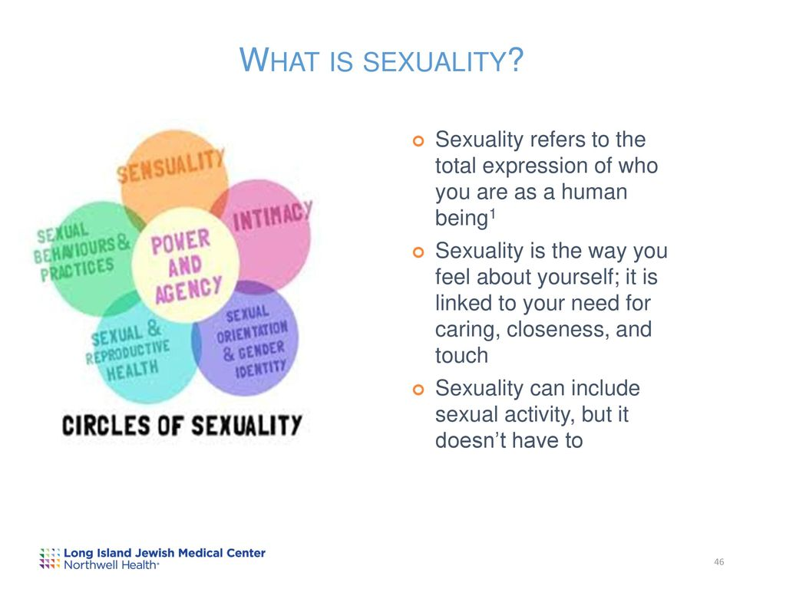 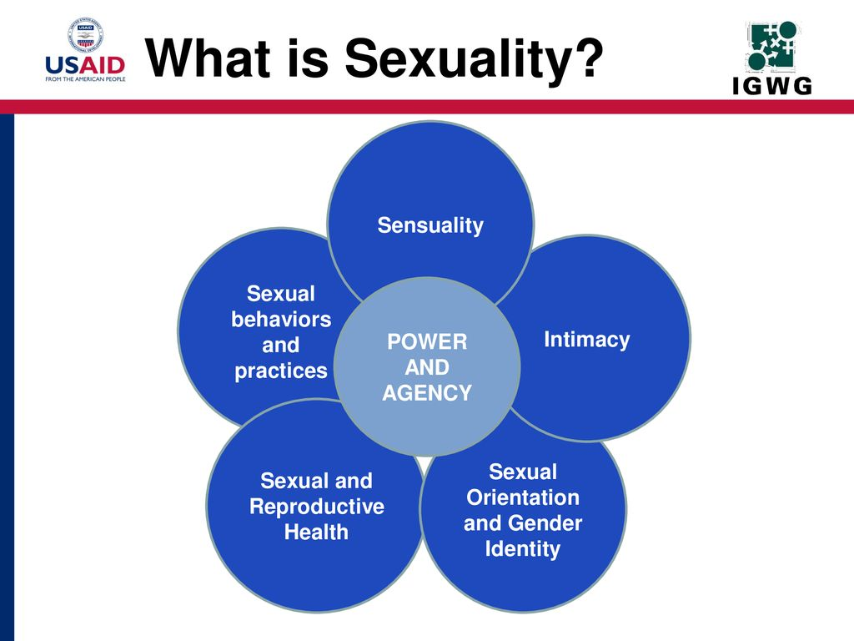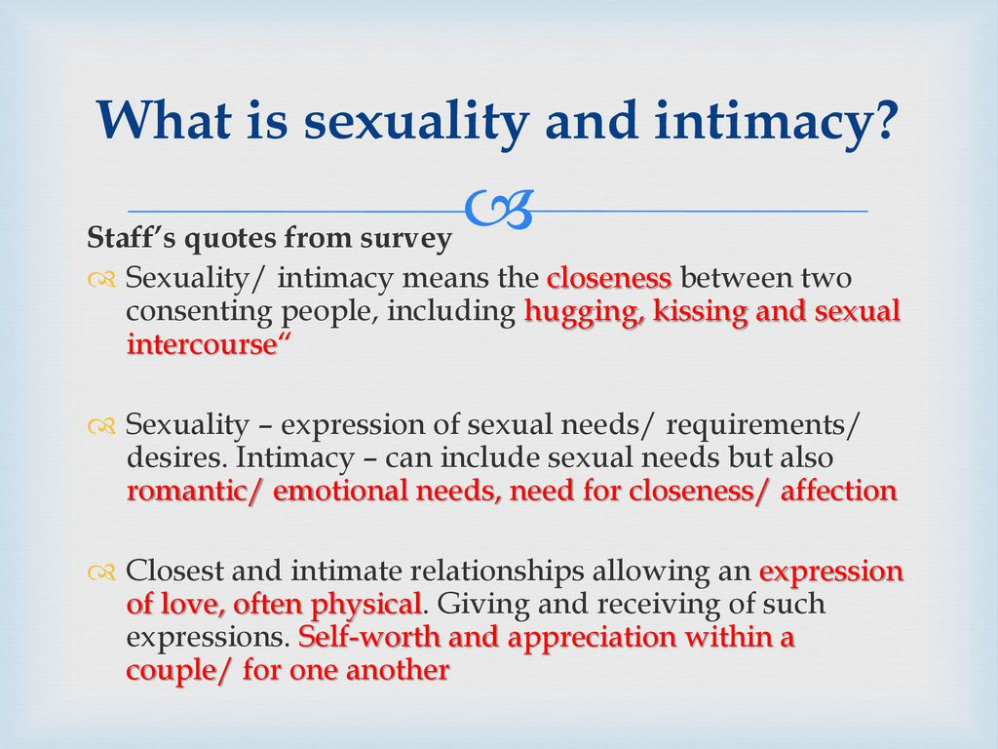

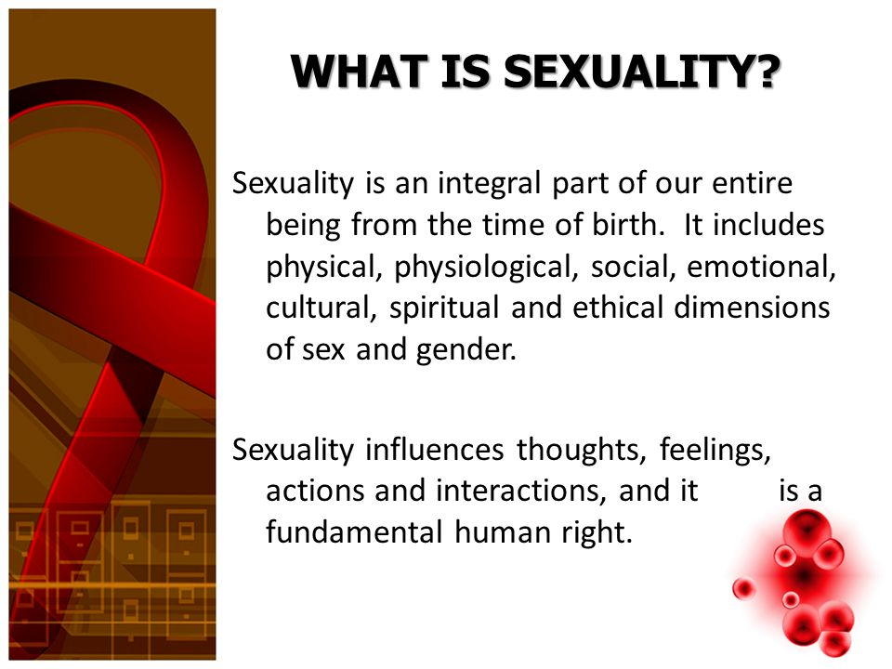

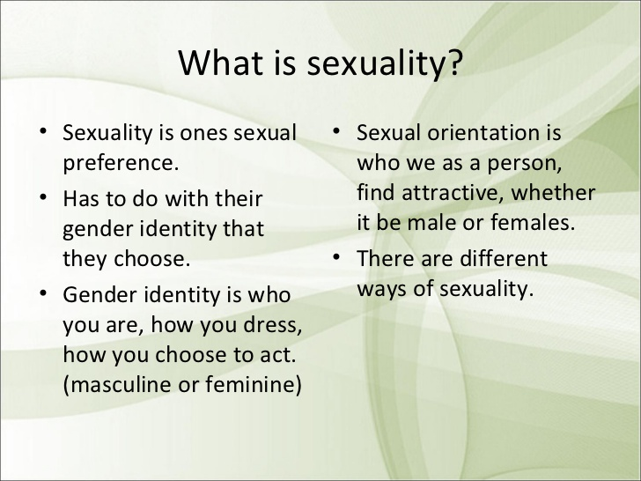

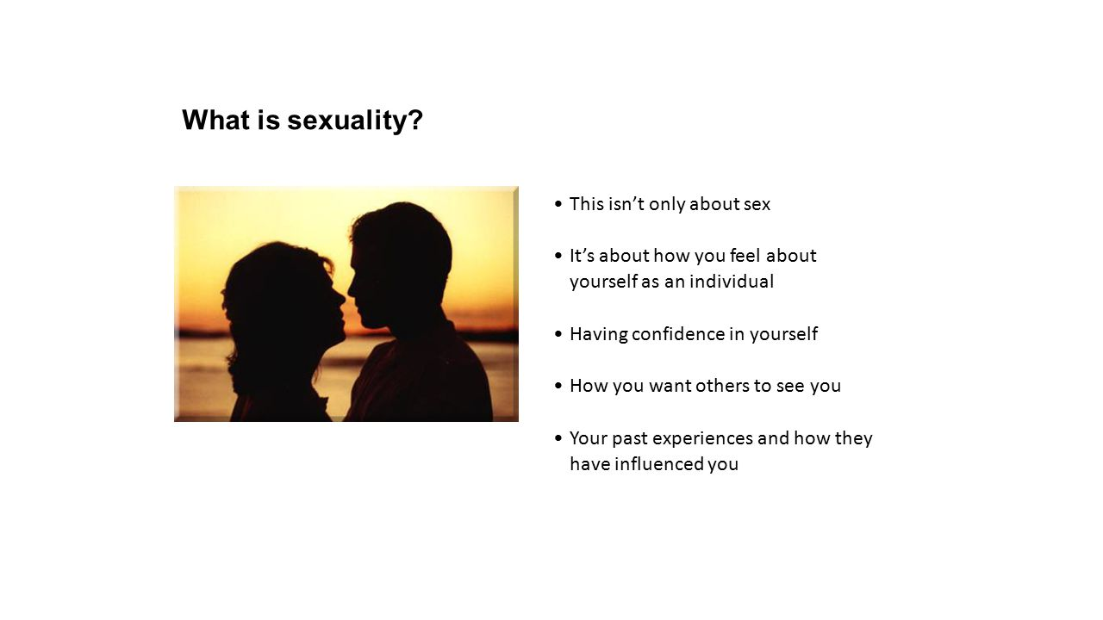

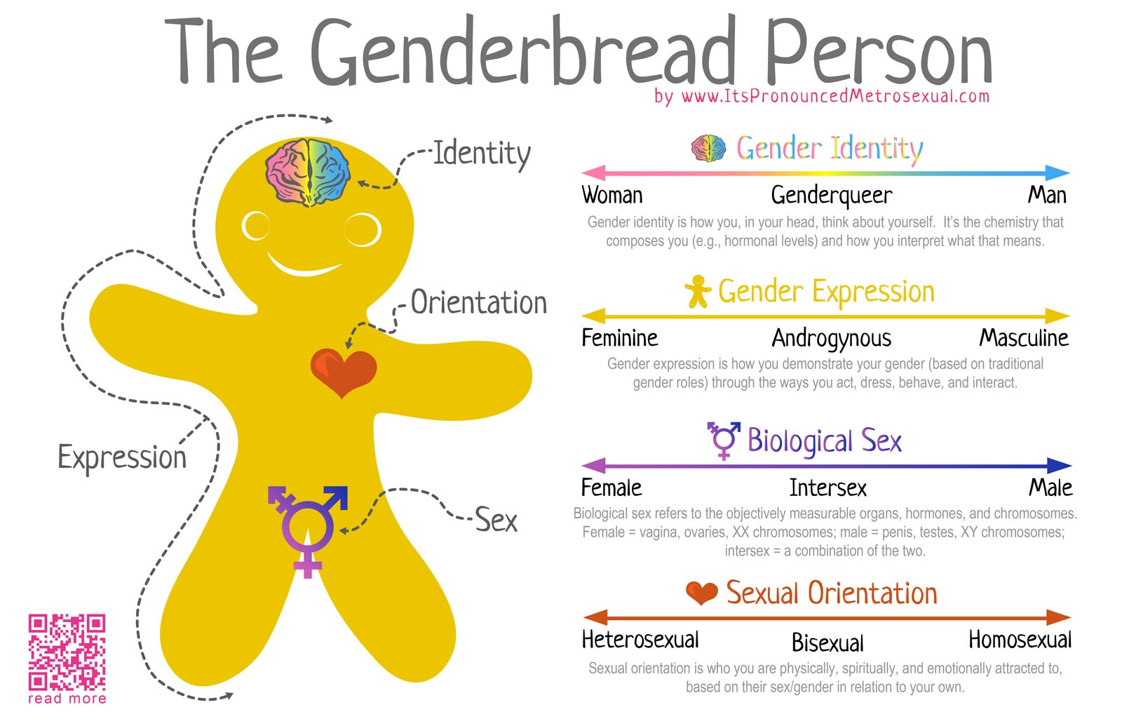

**Sexual orientation** is about who you’re attracted to and want to have relationships with. Sexual orientations include gay, lesbian, straight, bisexual, and asexual.

**Sexual orientation** is about who you’re attracted to and who you feel drawn to romantically, emotionally, and sexually. It’s different than [**gender identity**](https://www.plannedparenthood.org/learn/sexual-orientation-gender/gender-gender-identity). Gender identity isn’t about who you’re attracted to, but about who you ARE — male, female, gender queer, etc.

**Sexual orientation** is about who you want to be with. **Gender identity** is about who you are.

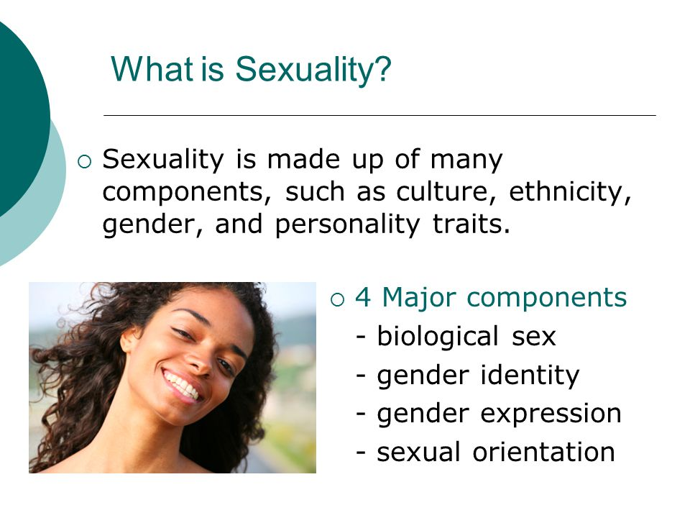

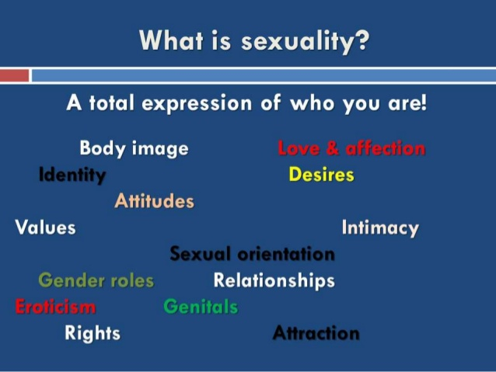

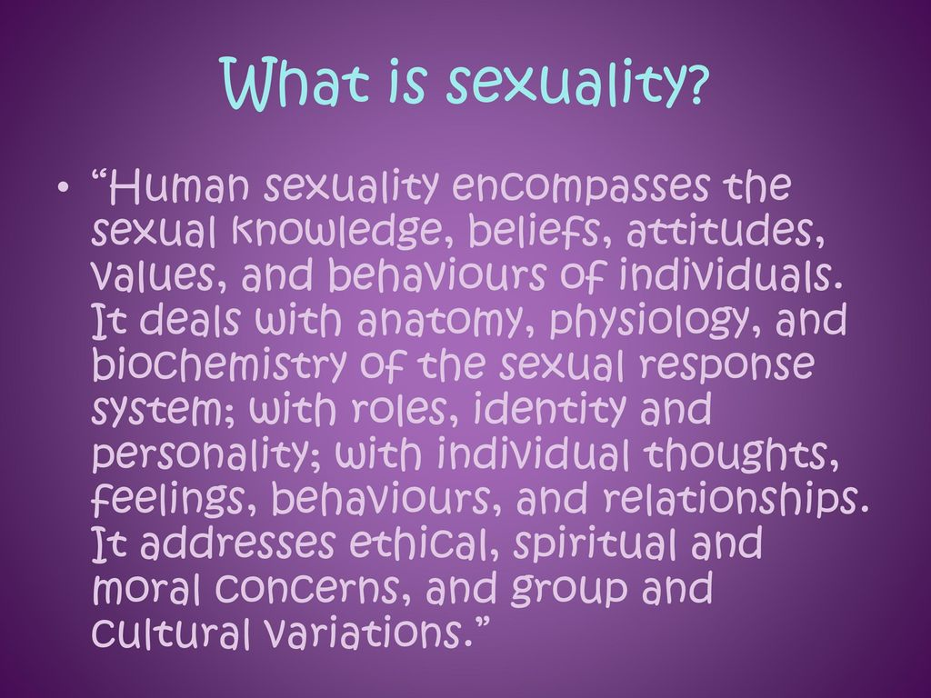

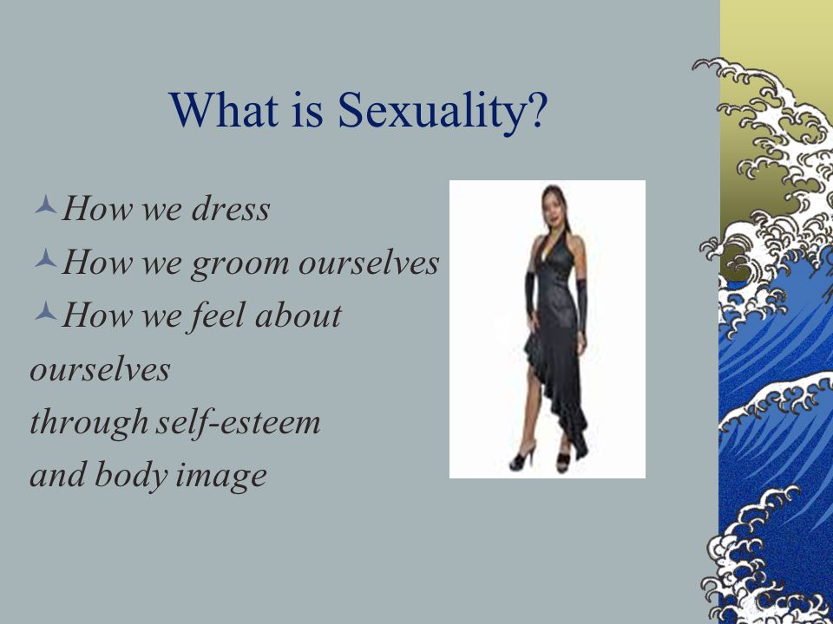

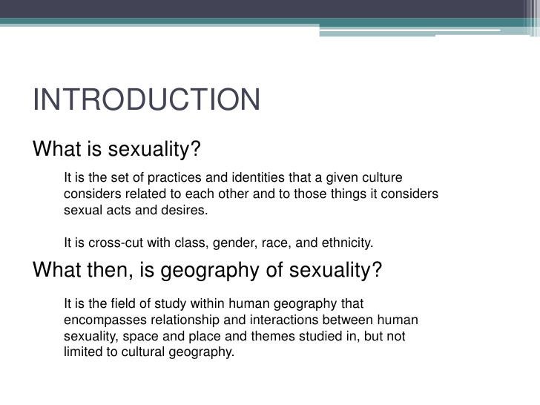

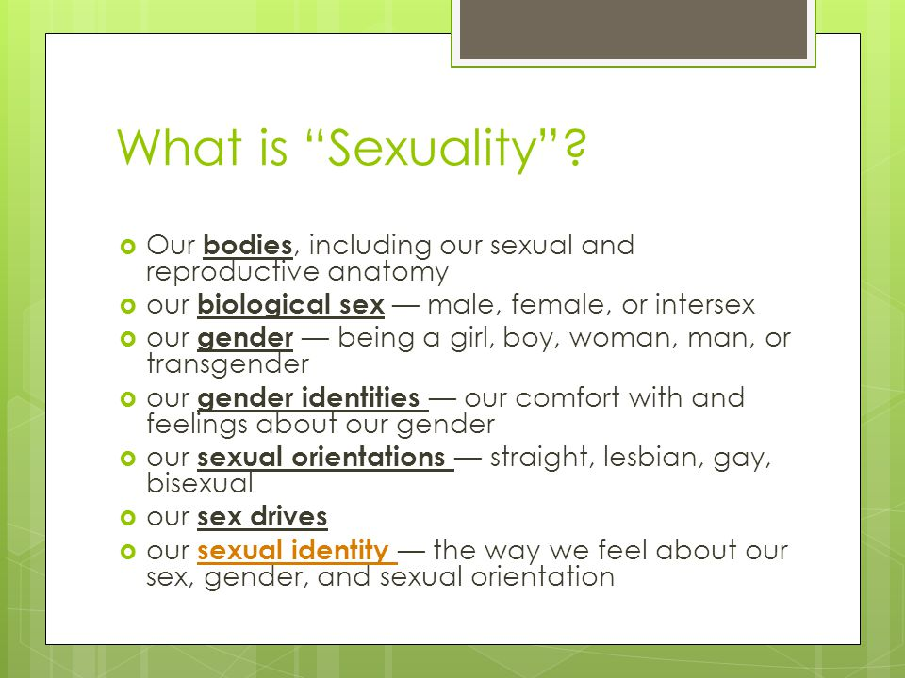



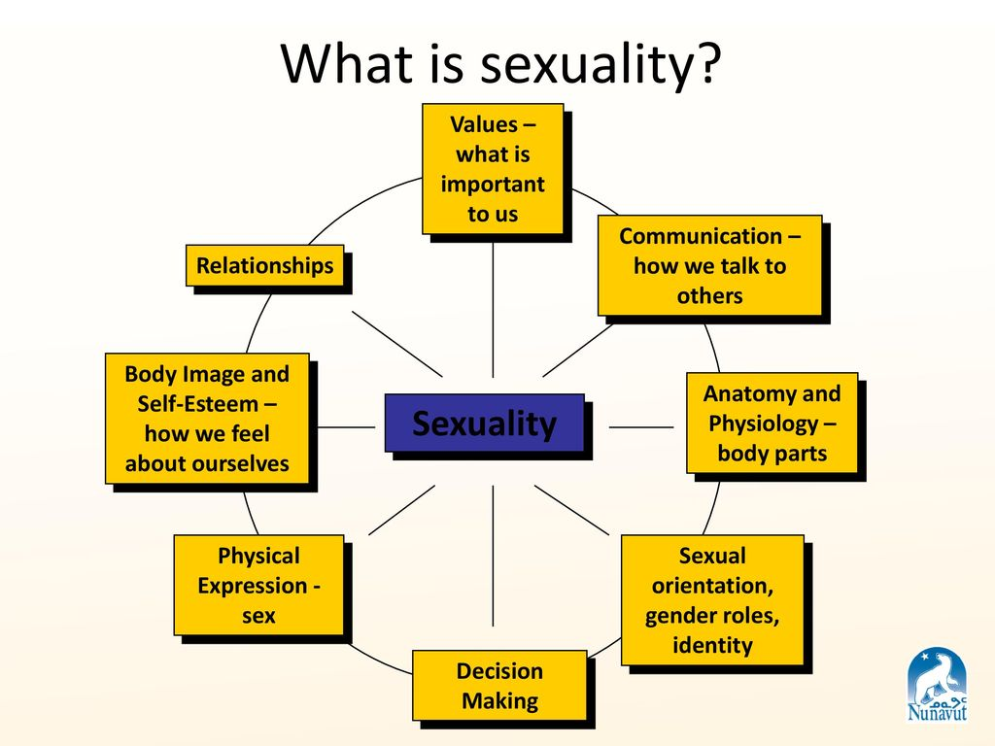]

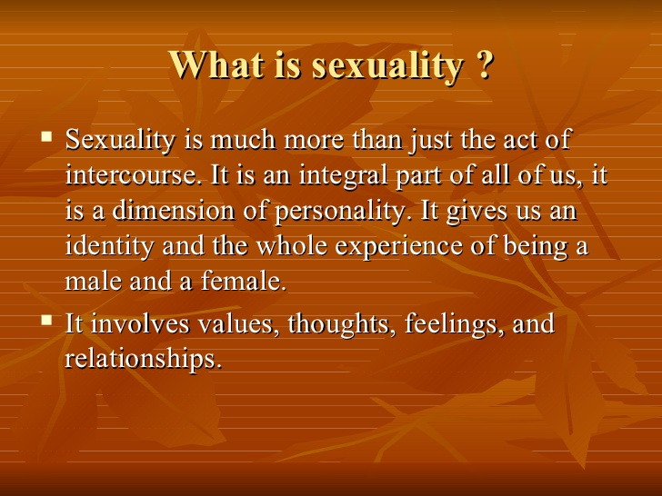

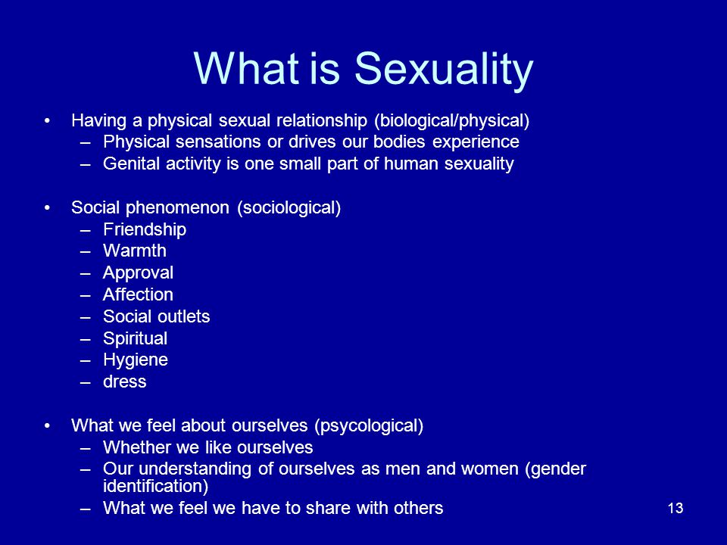

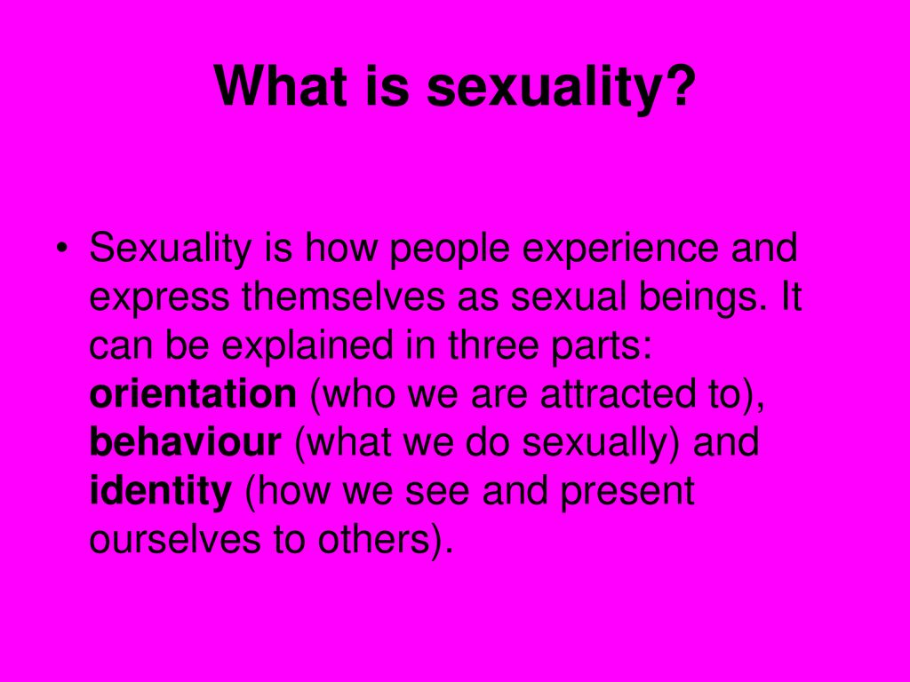

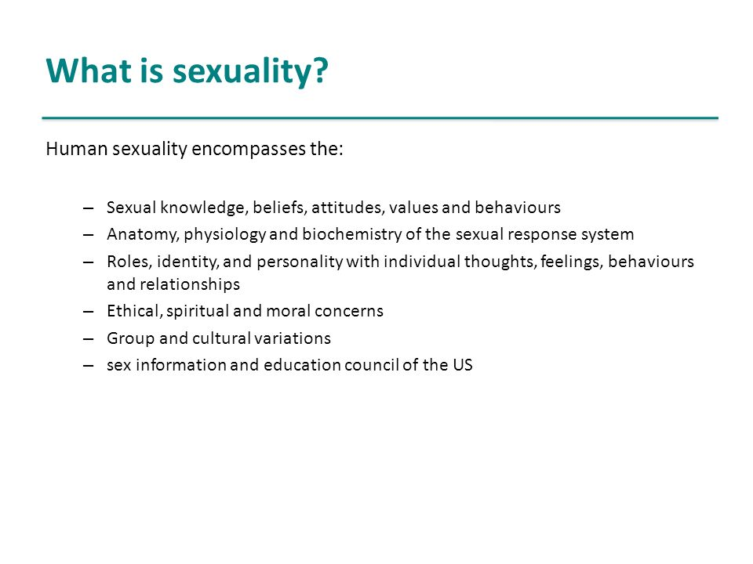

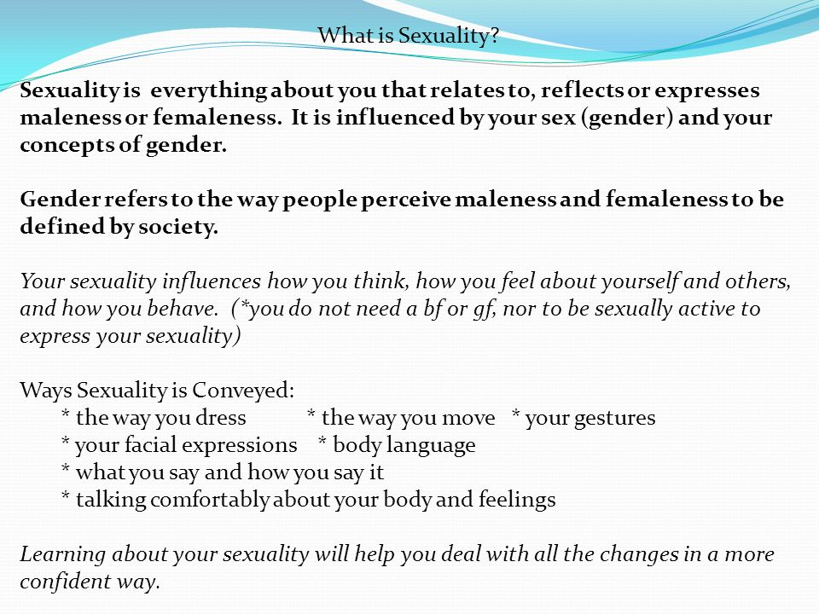

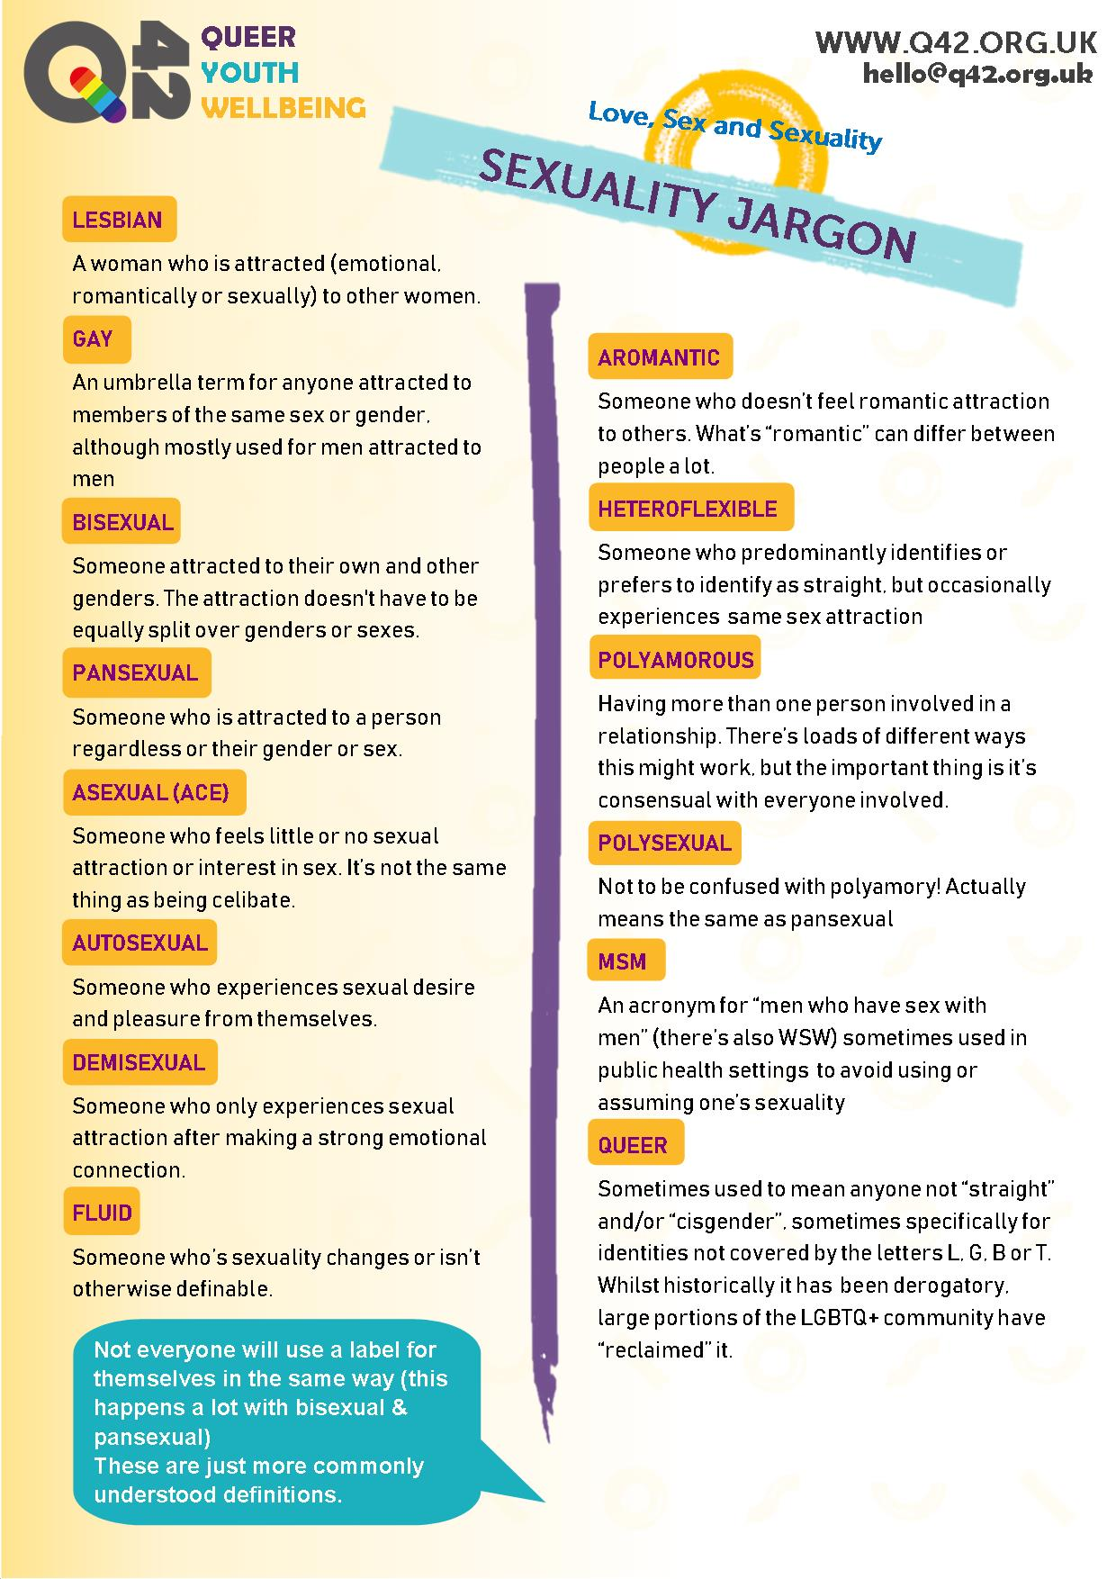

(Geneva) – **The United Nations Human Rights Council**, in a defining vote, adopted a resolution on June 30, 2016, on “Protection against violence and **discrimination** based on **sexual** orientation, and **gender identity**,” to **mandate** the appointment of an independent expert on the subject.

**SOGI** stands for sexual orientation and gender identity. Since we all have a sexual orientation and gender identity, it includes all of us. ... A **SOGI**-inclusive school means all of these experiences and identities are embraced and never cause for discrimination

SOGI is an inclusive term that represents all individuals regardless of sexual orientation or gender identity. It includes lesbian, gay, bisexual, transgender, queer, two-spirit, heterosexual and cisgender

**Sexuality** as a concept has been examined for many years. There are a number of definitions that cover various components of this concept. While there is no single agreed upon definition, the two definitions of sexuality below promote an understanding of sexuality

**Sexuality** is a central aspect of being human throughout life and encompasses sex, gender identities and roles, sexual orientation, eroticism, pleasure, intimacy and reproduction. Sexuality is experienced and expressed in thoughts, fantasies, desires, beliefs, attitudes, values, behaviours, practices, roles and relationships. While sexuality can include all of these dimensions, not all of them are always experienced or expressed. Sexuality is influenced by the interaction of biological, psychological, social, economic, political, cultural, ethical, legal, historical and religious and spiritual factors. ***WHO draft working definition 2002***

* Human sexuality encompasses the sexual knowledge, beliefs, attitudes, values and behaviours of individuals. Its various dimensions include the anatomy, physiology and biochemistry of the sexual response system; identity, orientation, roles and personality; and thoughts, feelings, and relationships. The expressions of sexuality are influenced by ethical, spiritual, cultural, and moral concerns.

**Sexual and Gender Identities**

* A concept that refers to how people view themselves sexually in terms of whom they are attracted to. This refers specifically to whether an individual is attracted to people of the same gender, a different gender, more than one gender and which category of these identities they want to adopt for themselves.

**Terms**

* **Heterosexual:** An individual who is sexually attracted to people of a gender other than their own and/or who identifies as being heterosexual.
* **Homosexual:** An individual who is sexually attracted to people of the same gender as their own, and/or who identifies as being homosexual.
* **Gay:** A man who is sexually attracted to other men and/or identifies as gay. This term can also be used to describe any person (man or woman) who experiences sexual attraction to people of the same gender.
* **Bisexual:** An individual who is sexually attracted to people of the same gender and also to people of a gender other than their own.
* **Asexual:** An individual who feels no sexual attraction towards other individuals.
* **Transgender Person**: An individual who does not identify with the gender assigned to them. They may or may not consider themselves a ‘third sex’. Transgender people can be men who dress, act or behave like women or women who dress, act or behave like men. They do not, however, necessarily identify as homosexual.
* **Transsexual Person**: An individual who wants to change from the gender they have been assigned at birth to another gender. Some have surgery, hormonal medication, or other procedures to make these changes. They may or may not identify as homosexual, bisexual or heterosexual. They may be female to male transsexuals, male to female transsexuals or choose not to be identified as either.

**Transvestite: An** individual who dresses in the clothing that is typically worn by people of another gender *for purposes of sexual arousal/gratification*. Transvestites are often men who dress in the clothing typically worn by women. They are also known as cross-dressers

**Intersectionalities**

* Gender and sexuality are one of several axes of power and discrimination – others being class, caste, ethnicity, race, location, ability, sexuality etc.

**Gender identity**

**Gender identity** is the personal sense of one's own **gender**. **Gender identity** can correlate with assigned sex at birth or can differ from it. ... Some people do not identify with some, or all, of the aspects of **gender** assigned to their biological sex; some of those people are transgender, gender queer or non-binary.

* **Homosexual**

Sexually attracted to people of one's own sex.

**Bisexual**

Sexually attracted not exclusively to people of one particular gender; attracted to both men and women.

**Pansexual**

Not limited in sexual choice with regard to biological sex, gender, or gender identity.

**Asexual**

Without sexual feelings or associations. “asexual individuals may still experience attraction but this attraction doesn't need to be realized in any sexual manner"

**Heterosexual**

Sexually attracted to people of the opposite sex.

**Queer**

The term queer can include a variety of sexual identities and gender identities that are anything other than straight and cisgender.

In the past, “queer” was a word used to hurt and insult people. Some people still find it offensive, particularly those who remember when that word was used in a painful way. Others now use the word with pride to identify themselves.

You may not want to refer to someone as “queer” unless you know that’s how they identify themselves. When talking to someone about their sexual orientation, use the terms that they use. It’s okay (and often encouraged!) to ask what labels folks prefer.